Topic 4: Dynamic Programming

Experiment 1: Dice Throw Problem
Aim: Given the number of sides on a die, the number of dice, and a target sum, use dynamic programming to count the number of ways to roll the dice so they sum to the target.
Program:
def dice_throw_ways(num_sides, num_dice, target):
# dp[d][s] = number of ways to get sum s using d dice
dp = [[0] * (target + 1) for _ in range(num_dice + 1)]
dp[0][0] = 1

for d in range(1, num_dice + 1):
for s in range(1, target + 1):
for face in range(1, num_sides + 1):
if s - face >= 0:
dp[d][s] += dp[d - 1][s - face]

return dp[num_dice][target]

test_cases = [
(6, 2, 7),
(4, 3, 10),
]

for sides, dice, target in test_cases:
ways = dice_throw_ways(sides, dice, target)
print(f"Input: sides = {sides}, dice = {dice}, target sum = {target}")
print(f"Output: Number of ways to reach sum {target}: {ways}")
print()
Output:
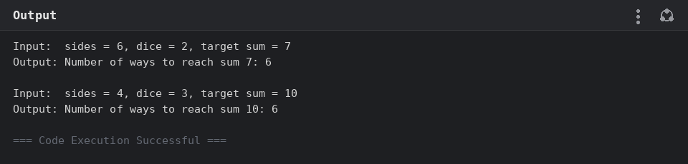

Experiment 2: Assembly Line Scheduling (Two Lines)
Aim: Given station times, transfer times between two assembly lines, and entry/exit times, use dynamic programming to find the minimum time to process a product from start to end.
Program:
def min_assembly_time(a1, a2, t1, t2, e1, e2, x1, x2):
n = len(a1)
f1 = [0] * n
f2 = [0] * n

f1[0] = e1 + a1[0]
f2[0] = e2 + a2[0]

for i in range(1, n):
f1[i] = min(f1[i - 1] + a1[i], f2[i - 1] + t2[i - 1] + a1[i])
f2[i] = min(f2[i - 1] + a2[i], f1[i - 1] + t1[i - 1] + a2[i])

return min(f1[n - 1] + x1, f2[n - 1] + x2)

# Classic assembly-line scheduling instance (CLRS)
a1 = [7, 9, 3, 4, 8, 4]
a2 = [8, 5, 6, 4, 5, 7]
t1 = [2, 3, 1, 3, 4] # Line 1 -> Line 2, after stations 1..5
t2 = [2, 1, 2, 2, 1] # Line 2 -> Line 1, after stations 1..5
e1, e2 = 2, 4
x1, x2 = 3, 2

result = min_assembly_time(a1, a2, t1, t2, e1, e2, x1, x2)

print("Input:")
print(f" a1 (Line 1 station times) = {a1}")
print(f" a2 (Line 2 station times) = {a2}")
print(f" t1 (Line1->Line2 transfer times) = {t1}")
print(f" t2 (Line2->Line1 transfer times) = {t2}")
print(f" e1, e2 (entry times) = {e1}, {e2}")
print(f" x1, x2 (exit times) = {x1}, {x2}")
print()
print(f"Output: Minimum time required to process the product = {result}")
Output:
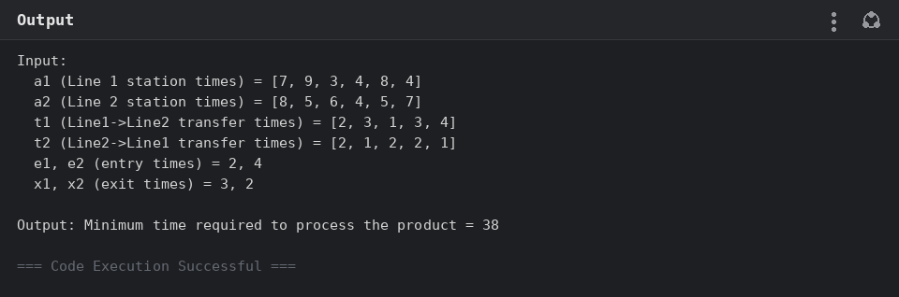

Experiment 3: Assembly Line Scheduling (Three Lines with Dependencies)
Aim: Extend assembly-line scheduling to three lines with transfer times between every pair of lines and sequential station dependencies, and find the minimum total production time.
Program:
def min_time_three_lines(station_times, transfer_times, dependencies):
"""Generalized assembly-line scheduling DP for k lines.

dp[i][line] = minimum time to complete station i, finishing on `line`.
Moving from station i-1 (any line) to station i on `line` costs the
station's own time plus a transfer penalty if the line changes.
`dependencies` records that station i's work depends on station i-1's
result, which the DP already respects by processing stations in order.
"""
num_lines = len(station_times)
num_stations = len(station_times[0])

dp = [[0] * num_lines for _ in range(num_stations)]
for line in range(num_lines):
dp[0][line] = station_times[line][0]

for i in range(1, num_stations):
for line in range(num_lines):
best = float("inf")
for prev_line in range(num_lines):
cost = dp[i - 1][prev_line] + station_times[line][i]
if prev_line != line:
cost += transfer_times[prev_line][line]
best = min(best, cost)
dp[i][line] = best

return min(dp[num_stations - 1])

station_times = [
[5, 9, 3], # Line 1
[6, 8, 4], # Line 2
[7, 6, 5], # Line 3
]
transfer_times = [
[0, 2, 3],
[2, 0, 4],
[3, 4, 0],
]
dependencies = [(0, 1), (1, 2)]

result = min_time_three_lines(station_times, transfer_times, dependencies)

print("Input:")
print(f" Station times: Line 1 = {station_times[0]}, Line 2 = {station_times[1]}, Line 3 = {station_times[2]}")
print(f" Transfer times = {transfer_times}")
print(f" Dependencies = {dependencies}")
print()
print(f"Output: Minimum total production time = {result}")
Output:
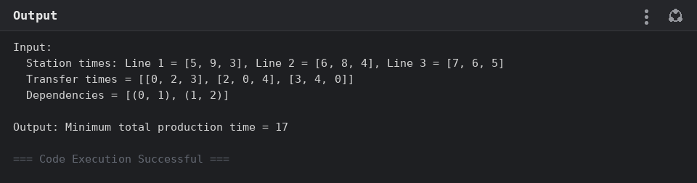

Experiment 4: Minimum Path Distance (TSP via Matrix / DP)
Aim: Given a distance matrix between cities, find the minimum-cost round trip that visits every city exactly once, using the Held-Karp dynamic programming algorithm.
Program:
def tsp_min_distance(dist):
"""Held-Karp dynamic programming solution to TSP.
dp[mask][i] = minimum cost to have visited the set of cities `mask`,
ending at city i, having started at city 0."""
n = len(dist)
dp = [[float("inf")] * n for _ in range(1 << n)]
dp[1][0] = 0 # start at city 0, only city 0 visited

for mask in range(1 << n):
for i in range(n):
if dp[mask][i] == float("inf") or not (mask & (1 << i)):
continue
for j in range(n):
if mask & (1 << j):
continue
new_mask = mask | (1 << j)
new_cost = dp[mask][i] + dist[i][j]
if new_cost < dp[new_mask][j]:
dp[new_mask][j] = new_cost

full_mask = (1 << n) - 1
return min(dp[full_mask][i] + dist[i][0] for i in range(1, n))

test_cases = [
[[0, 10, 15, 20],
[10, 0, 35, 25],
[15, 35, 0, 30],
[20, 25, 30, 0]],
[[0, 10, 10, 10],
[10, 0, 10, 10],
[10, 10, 0, 10],
[10, 10, 10, 0]],
[[0, 1, 2, 3],
[1, 0, 4, 5],
[2, 4, 0, 6],
[3, 5, 6, 0]],
]

for matrix in test_cases:
result = tsp_min_distance(matrix)
print("Input:")
for row in matrix:
print(" ", row)
print(f"Output: {result}")
print()
Output:
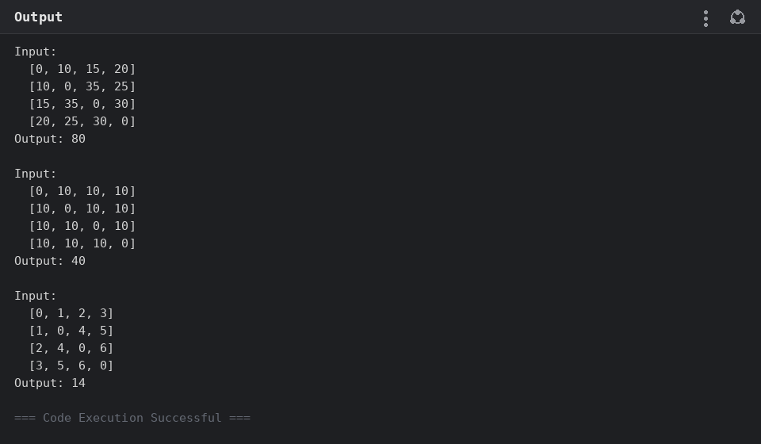

Experiment 5: Traveling Salesperson Problem — Adding a Fifth City
Aim: Extend the Traveling Salesperson Problem from 4 cities (A, B, C, D) to 5 cities (adding E) with symmetric distances, and find the shortest route and its total distance.
Program:
def tsp_min_route(dist, names):
n = len(dist)
dp = [[float("inf")] * n for _ in range(1 << n)]
parent = [[-1] * n for _ in range(1 << n)]
dp[1][0] = 0

for mask in range(1 << n):
for i in range(n):
if dp[mask][i] == float("inf") or not (mask & (1 << i)):
continue
for j in range(n):
if mask & (1 << j):
continue
new_mask = mask | (1 << j)
new_cost = dp[mask][i] + dist[i][j]
if new_cost < dp[new_mask][j]:
dp[new_mask][j] = new_cost
parent[new_mask][j] = i

full_mask = (1 << n) - 1
best_cost = float("inf")
best_last = -1
for i in range(1, n):
cost = dp[full_mask][i] + dist[i][0]
if cost < best_cost:
best_cost = cost
best_last = i

# Reconstruct the path
path = []
mask = full_mask
last = best_last
while last != -1:
path.append(last)
prev = parent[mask][last]
mask ^= (1 << last)
last = prev
path.reverse()
path.append(0)

return [names[i] for i in path], best_cost

names = ["A", "B", "C", "D", "E"]
# distances[i][j]
d = {
("A", "B"): 10, ("A", "C"): 15, ("A", "D"): 20, ("A", "E"): 25,
("B", "C"): 35, ("B", "D"): 25, ("B", "E"): 30,
("C", "D"): 30, ("C", "E"): 20,
("D", "E"): 15,
}
n = len(names)
dist = [[0] * n for _ in range(n)]
for i in range(n):
for j in range(n):
if i != j:
key = (names[i], names[j]) if (names[i], names[j]) in d else (names[j], names[i])
dist[i][j] = d[key]

route, total = tsp_min_route(dist, names)

print("Input: symmetric distances between A, B, C, D, E")
for (a, b), val in d.items():
print(f" {a}-{b}: {val}")
print()
print(f"Output: Shortest route = {' -> '.join(route)}, Total distance = {total}")
Output:
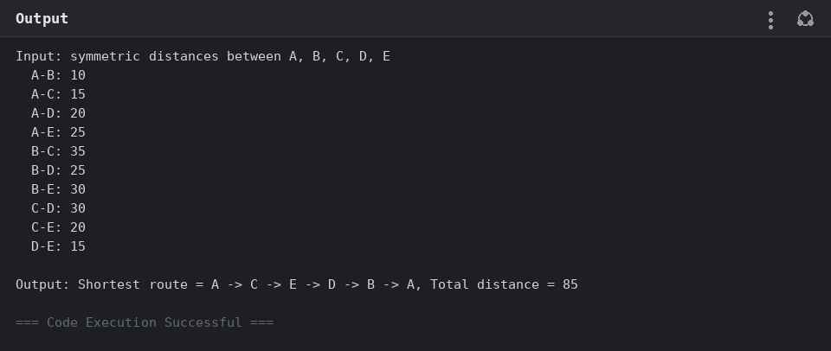

Experiment 6: Longest Palindromic Substring
Aim: Given a string s, use dynamic programming (a table of palindromic sub-ranges) to find the longest substring of s that reads the same forwards and backwards.
Program:
def longest_palindrome(s):
n = len(s)
if n == 0:
return ""
# dp[i][j] = True if s[i..j] is a palindrome
dp = [[False] * n for _ in range(n)]
start, max_len = 0, 1

for i in range(n):
dp[i][i] = True

for length in range(2, n + 1):
for i in range(n - length + 1):
j = i + length - 1
if s[i] == s[j] and (length == 2 or dp[i + 1][j - 1]):
dp[i][j] = True
if length > max_len:
start, max_len = i, length

return s[start:start + max_len]

test_cases = ["babad", "cbbd"]

for s in test_cases:
result = longest_palindrome(s)
print(f'Input: s = "{s}"')
print(f'Output: "{result}"')
print()
Output:
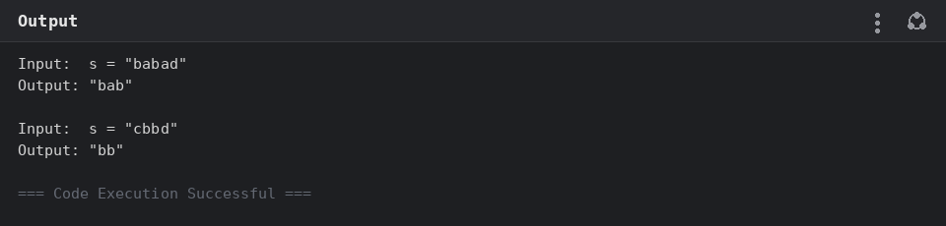

Experiment 7: Longest Substring Without Repeating Characters
Aim: Given a string s, find the length of the longest substring that does not contain any repeated characters, using a sliding window.
Program:
def length_of_longest_substring(s):
last_seen = {}
start = 0
max_len = 0

for i, ch in enumerate(s):
if ch in last_seen and last_seen[ch] >= start:
start = last_seen[ch] + 1
last_seen[ch] = i
max_len = max(max_len, i - start + 1)

return max_len

test_cases = ["abcabcbb", "bbbbb", "pwwkew"]

for s in test_cases:
result = length_of_longest_substring(s)
print(f'Input: s = "{s}"')
print(f"Output: {result}")
print()
Output:
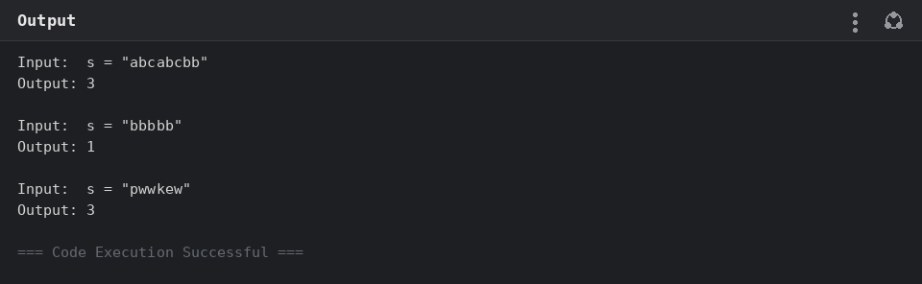

Experiment 8: Word Break
Aim: Given a string s and a dictionary of words, use dynamic programming to determine whether s can be segmented into a space-separated sequence of one or more dictionary words.
Program:
def word_break(s, word_dict):
words = set(word_dict)
n = len(s)
dp = [False] * (n + 1)
dp[0] = True

for i in range(1, n + 1):
for j in range(i):
if dp[j] and s[j:i] in words:
dp[i] = True
break

return dp[n]

test_cases = [
("leetcode", ["leet", "code"]),
("applepenapple", ["apple", "pen"]),
("catsandog", ["cats", "dog", "sand", "and", "cat"]),
]

for s, word_dict in test_cases:
result = word_break(s, word_dict)
print(f'Input: s = "{s}", wordDict = {word_dict}')
print(f"Output: {result}")
print()
Output:
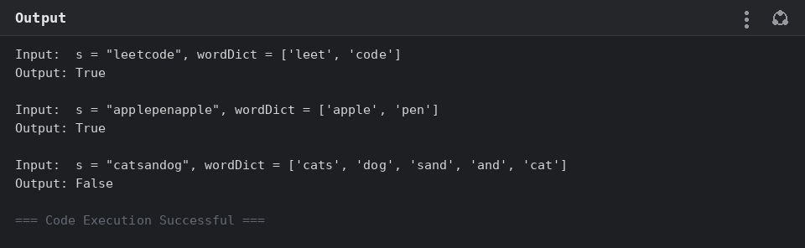

Experiment 9: Word Break — Dictionary Segmentation
Aim: Given a fixed dictionary of words, determine whether an input string can be segmented into dictionary words and reconstruct one valid segmentation.
Program:
def word_break_segments(s, word_dict):
"""Returns one valid space-separated segmentation of s using words
from word_dict, or None if s cannot be segmented."""
words = set(word_dict)
n = len(s)
dp = [None] * (n + 1)
dp[0] = []

for i in range(1, n + 1):
for j in range(i):
if dp[j] is not None and s[j:i] in words:
dp[i] = dp[j] + [s[j:i]]
break

return dp[n]

dictionary = {"i", "like", "sam", "sung", "samsung", "mobile",
"ice", "cream", "icecream", "man", "go", "mango"}

test_cases = ["ilike", "ilikesamsung"]

for s in test_cases:
segments = word_break_segments(s, dictionary)
print(f'Input: "{s}"')
if segments:
print(f'Output: Yes (can be segmented as "{" ".join(segments)}")')
else:
print("Output: No")
print()
Output:
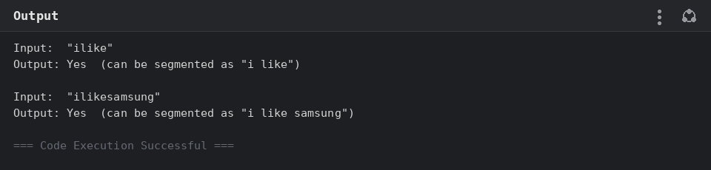

Experiment 10: Text Justification
Aim: Given an array of words and a maximum line width, greedily pack words into lines and pad them with spaces so each line (except the last) is fully left- and right-justified to exactly maxWidth characters.
Program:
def full_justify(words, max_width):
lines = []
current_line = []
current_len = 0

for word in words:
if current_len + len(current_line) + len(word) > max_width:
# Distribute spaces across the current line
num_gaps = len(current_line) - 1
if num_gaps == 0:
line = current_line[0] + " " * (max_width - current_len)
else:
spaces, extra = divmod(max_width - current_len, num_gaps)
line = ""
for i, w in enumerate(current_line[:-1]):
line += w + " " * (spaces + (1 if i < extra else 0))
line += current_line[-1]
lines.append(line)
current_line, current_len = [], 0

current_line.append(word)
current_len += len(word)

# Last line: left-justified
last_line = " ".join(current_line)
last_line += " " * (max_width - len(last_line))
lines.append(last_line)

return lines

test_cases = [
(["This", "is", "an", "example", "of", "text", "justification."], 16),
(["What", "must", "be", "acknowledgment", "shall", "be"], 16),
]

for words, width in test_cases:
result = full_justify(words, width)
print(f"Input: words = {words}, maxWidth = {width}")
print("Output:")
for line in result:
print(f' "{line}"')
print()
Output:
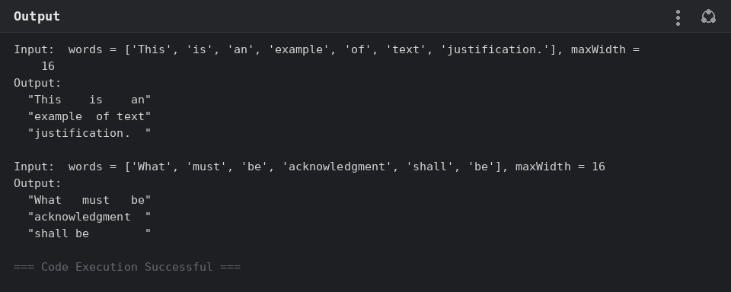

Experiment 11: WordFilter — Prefix and Suffix Search
Aim: Design a WordFilter data structure that, given a prefix and a suffix, returns the largest index of a dictionary word matching both, or -1 if none matches.
Program:
class WordFilter:
def __init__(self, words):
# Store the largest index for every (prefix, suffix) combination
# actually present in some word, built directly from the word list.
self.best_index = {}
for index, word in enumerate(words):
n = len(word)
for i in range(n + 1):
prefix = word[:i]
for j in range(n + 1):
suffix = word[j:]
self.best_index[(prefix, suffix)] = index

def f(self, pref, suff):
return self.best_index.get((pref, suff), -1)

word_filter = WordFilter(["apple"])
result = word_filter.f("a", "e")

print('Input: WordFilter(["apple"]); f("a", "e")')
print(f"Output: {result}")
print('Explanation: the word at index 0 has prefix "a" and suffix "e".')
Output:
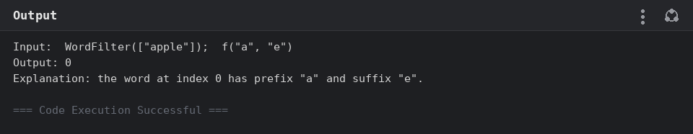

Experiment 12: Floyd's Algorithm — All-Pairs Shortest Paths and Threshold City
Aim: Implement Floyd's algorithm to compute all-pairs shortest paths, display the distance matrix before and after, and use it to find the city with the fewest neighbors within a distance threshold; also demonstrate the algorithm on a directed graph with negative edge weights.
Program:
INF = float("inf")

def floyd_warshall(n, edges, directed=False):
dist = [[INF] * n for _ in range(n)]
for i in range(n):
dist[i][i] = 0
for u, v, w in edges:
dist[u][v] = min(dist[u][v], w)
if not directed:
dist[v][u] = min(dist[v][u], w)

before = [row[:] for row in dist]
for k in range(n):
for i in range(n):
for j in range(n):
if dist[i][k] + dist[k][j] < dist[i][j]:
dist[i][j] = dist[i][k] + dist[k][j]

return before, dist

def print_matrix(matrix):
for row in matrix:
print(" ", ["INF" if v == INF else v for v in row])

def city_with_fewest_neighbors(n, dist, threshold):
best_city, best_count = -1, n + 1
for i in range(n):
count = sum(1 for j in range(n) if i != j and dist[i][j] <= threshold)
if count <= best_count:
best_city, best_count = i, count
return best_city

# --- Part 1: undirected city graph, threshold query -----------------------
n = 4
edges = [[0, 1, 3], [1, 2, 1], [1, 3, 4], [2, 3, 1]]
threshold = 4

before, after = floyd_warshall(n, edges)

print(f"Input: n = {n}, edges = {edges}, distanceThreshold = {threshold}")
print("\nDistance matrix BEFORE Floyd's algorithm:")
print_matrix(before)
print("\nDistance matrix AFTER Floyd's algorithm:")
print_matrix(after)

result = city_with_fewest_neighbors(n, after, threshold)
print(f"\nOutput: {result}")

# --- Part 2: directed city network with negative edge weights -------------
print("\n" + "-" * 50 + "\n")

city_edges = [
(0, 1, 3), (0, 2, 8), (0, 3, -4),
(1, 3, 1), (1, 2, 4),
(2, 0, 2),
(3, 2, -5), (3, 1, 6),
]

before2, after2 = floyd_warshall(4, city_edges, directed=True)

print("Input: directed city network (negative weights allowed)")
labels = [1, 2, 3, 4]
for u, v, w in city_edges:
print(f" City {labels[u]} -> City {labels[v]}: {w}")

print("\nDistance matrix BEFORE Floyd's algorithm:")
print_matrix(before2)
print("\nDistance matrix AFTER Floyd's algorithm:")
print_matrix(after2)

print(f"\nOutput: City 1 to City 3 = {after2[0][2]}")
Output:
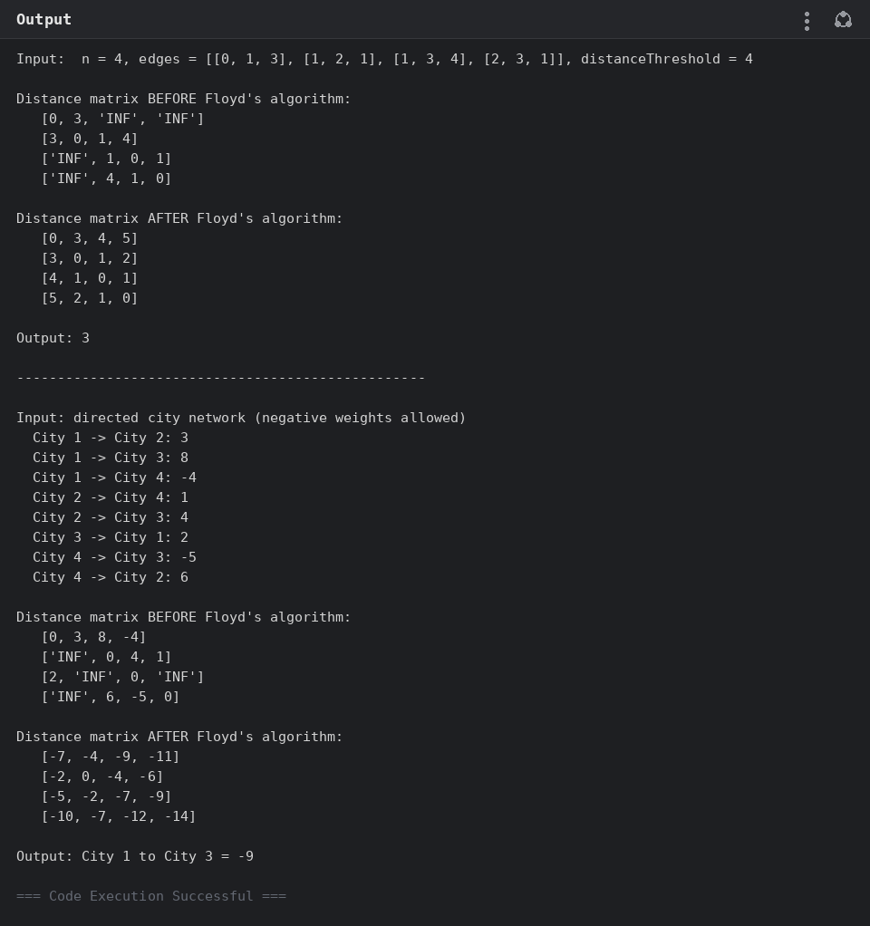

Experiment 13: Floyd's Algorithm — Simulating a Link Failure
Aim: Implement Floyd's algorithm on a 6-router network, then simulate the Router B – Router D link failing, updating the distance matrix and comparing the shortest path from Router A to Router F before and after the failure.
Program:
INF = float("inf")

def floyd_warshall(n, edges):
dist = [[INF] * n for _ in range(n)]
for i in range(n):
dist[i][i] = 0
for u, v, w in edges:
dist[u][v] = min(dist[u][v], w)
dist[v][u] = min(dist[v][u], w)
for k in range(n):
for i in range(n):
for j in range(n):
if dist[i][k] + dist[k][j] < dist[i][j]:
dist[i][j] = dist[i][k] + dist[k][j]
return dist

def print_matrix(matrix, labels):
print(" " + " ".join(labels))
for label, row in zip(labels, matrix):
print(f" {label} ", ["INF" if v == INF else v for v in row])

labels = ["A", "B", "C", "D", "E", "F"]
idx = {name: i for i, name in enumerate(labels)}

edges = [
("A", "B", 1), ("A", "C", 5),
("B", "C", 2), ("B", "D", 1),
("C", "E", 3),
("D", "E", 1), ("D", "F", 6),
("E", "F", 2),
]
edge_indices = [(idx[u], idx[v], w) for u, v, w in edges]

before_fail = floyd_warshall(6, edge_indices)
print("Input: 6-router network")
for u, v, w in edges:
print(f" Router {u} to Router {v}: {w}")

print("\nShortest-path matrix BEFORE the B-D link fails:")
print_matrix(before_fail, labels)
print(f"\nRouter A to Router F BEFORE failure = {before_fail[idx['A']][idx['F']]}")

# Simulate the B-D link failing (remove that edge)
edges_after_failure = [(u, v, w) for u, v, w in edge_indices
if not ({u, v} == {idx["B"], idx["D"]})]
after_fail = floyd_warshall(6, edges_after_failure)

print("\nShortest-path matrix AFTER the B-D link fails:")
print_matrix(after_fail, labels)

print(f"\nOutput: Router A to Router F = {after_fail[idx['A']][idx['F']]}")
Output:
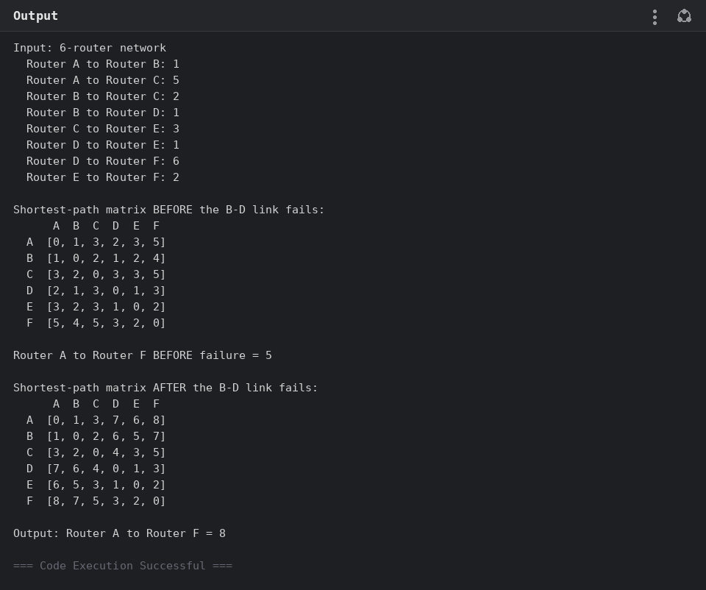

Experiment 14: Floyd's Algorithm — Additional Shortest-Path Cases
Aim: Apply Floyd's algorithm to a 5-city graph to find the city with fewest neighbors within a distance threshold, and to two small directed graphs to find specific shortest paths (C to A, and E to C).
Program:
INF = float("inf")

def floyd_warshall(n, edges, directed=True):
dist = [[INF] * n for _ in range(n)]
for i in range(n):
dist[i][i] = 0
for u, v, w in edges:
dist[u][v] = min(dist[u][v], w)
if not directed:
dist[v][u] = min(dist[v][u], w)
for k in range(n):
for i in range(n):
for j in range(n):
if dist[i][k] + dist[k][j] < dist[i][j]:
dist[i][j] = dist[i][k] + dist[k][j]
return dist

def print_matrix(matrix):
for row in matrix:
print(" ", ["INF" if v == INF else v for v in row])

def city_with_fewest_neighbors(n, dist, threshold):
best_city, best_count = -1, n + 1
for i in range(n):
count = sum(1 for j in range(n) if i != j and dist[i][j] <= threshold)
if count <= best_count:
best_city, best_count = i, count
return best_city

# --- Part 1: LeetCode-style example, n = 5 ---------------------------------
n, threshold = 5, 2
edges = [[0, 1, 2], [0, 4, 8], [1, 2, 3], [1, 4, 2], [2, 3, 1], [3, 4, 1]]
dist = floyd_warshall(n, edges, directed=False)

print(f"Input: n = {n}, edges = {edges}, distanceThreshold = {threshold}")
print("\nDistance matrix after Floyd's algorithm:")
print_matrix(dist)
result = city_with_fewest_neighbors(n, dist, threshold)
print(f"\nOutput: {result}")

# --- Part 2(a): small directed graph, C -> A -------------------------------
print("\n" + "-" * 50 + "\n")
labels_a = ["A", "B", "C", "D"]
idx_a = {n: i for i, n in enumerate(labels_a)}
edges_a = [("B", "A", 2), ("A", "C", 3), ("C", "D", 1), ("D", "A", 6), ("C", "B", 7)]
edges_a_idx = [(idx_a[u], idx_a[v], w) for u, v, w in edges_a]
dist_a = floyd_warshall(4, edges_a_idx, directed=True)

print("Input:")
for u, v, w in edges_a:
print(f" {u} to {v}: {w}")
print("\nDistance matrix after Floyd's algorithm:")
print_matrix(dist_a)
print(f"\nOutput: shortest path from C to A = {dist_a[idx_a['C']][idx_a['A']]}")

# --- Part 2(b): small directed graph, E -> C -------------------------------
print("\n" + "-" * 50 + "\n")
labels_b = ["A", "B", "C", "D", "E"]
idx_b = {n: i for i, n in enumerate(labels_b)}
edges_b = [
("C", "A", 2), ("A", "B", 4), ("B", "C", 1), ("B", "E", 6),
("E", "A", 1), ("A", "D", 5), ("D", "E", 2), ("E", "D", 4),
("D", "C", 1), ("C", "D", 3),
]
edges_b_idx = [(idx_b[u], idx_b[v], w) for u, v, w in edges_b]
dist_b = floyd_warshall(5, edges_b_idx, directed=True)

print("Input:")
for u, v, w in edges_b:
print(f" {u} to {v}: {w}")
print("\nDistance matrix after Floyd's algorithm:")
print_matrix(dist_b)
print(f"\nOutput: shortest path from E to C = {dist_b[idx_b['E']][idx_b['C']]}")
Output:
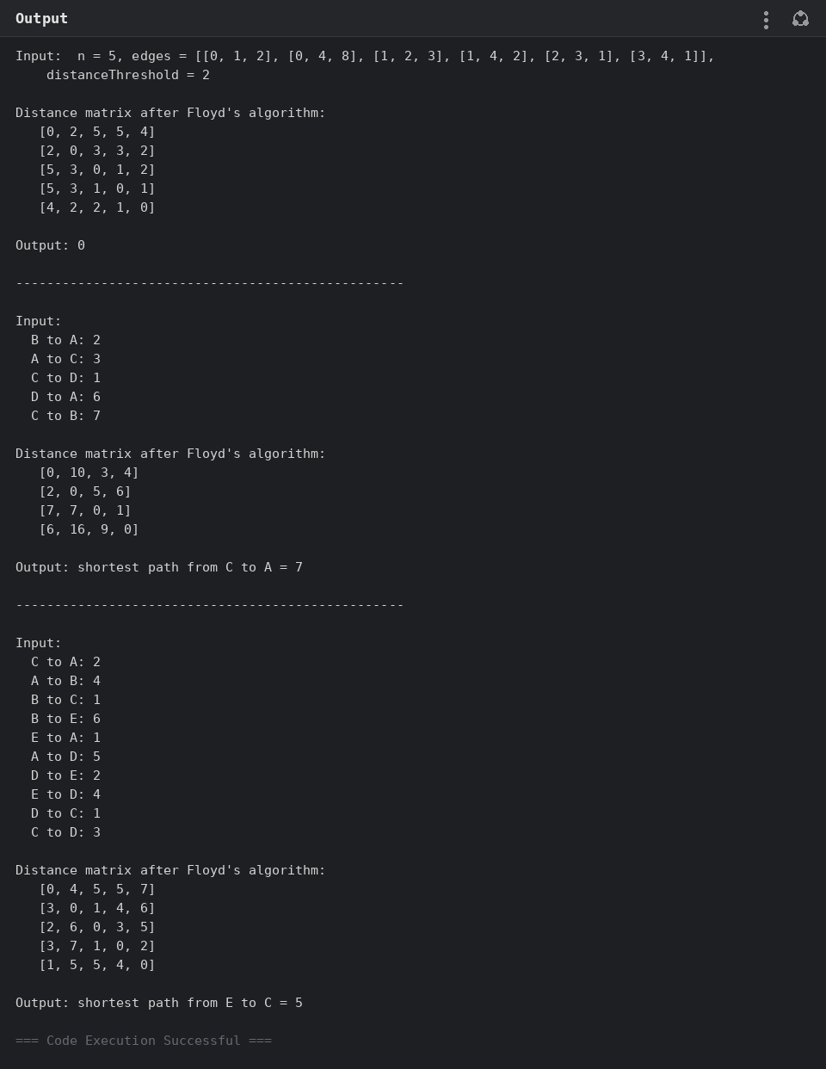

Experiment 15: Optimal Binary Search Tree — Keys A, B, C, D
Aim: Given keys A, B, C, D with access frequencies 0.1, 0.2, 0.4, 0.3, use dynamic programming to construct the Optimal Binary Search Tree, printing its minimum search cost, cost table, and root table.
Program:
def optimal_bst(keys, freq):
n = len(keys)
# cost[i][j] = optimal cost of the OBST built from keys[i..j]
cost = [[0.0] * n for _ in range(n)]
root = [[0] * n for _ in range(n)]

for i in range(n):
cost[i][i] = freq[i]
root[i][i] = i

for length in range(2, n + 1):
for i in range(n - length + 1):
j = i + length - 1
cost[i][j] = float("inf")
freq_sum = sum(freq[i:j + 1])
for r in range(i, j + 1):
left = cost[i][r - 1] if r > i else 0
right = cost[r + 1][j] if r < j else 0
total = left + right + freq_sum
if total < cost[i][j]:
cost[i][j] = total
root[i][j] = r

return cost[0][n - 1], cost, root

def print_cost_table(table, keys):
n = len(keys)
header = " " + " ".join(f"{j:>5}" for j in range(n))
print(header)
for i in range(n):
row = [f"{table[i][j]:>5.2f}" if j >= i else " " for j in range(n)]
print(f" {i} " + " ".join(row))

def print_root_table(table, keys):
n = len(keys)
header = " " + " ".join(f"{j:>3}" for j in range(n))
print(header)
for i in range(n):
row = [f"{table[i][j]:>3}" if j >= i else " " for j in range(n)]
print(f" {i} " + " ".join(row))

keys = ["A", "B", "C", "D"]
freq = [0.1, 0.2, 0.4, 0.3]

min_cost, cost_table, root_table = optimal_bst(keys, freq)

print(f"Input: Keys = {keys}, Frequencies = {freq}")
print(f"\nOutput: Minimum OBST cost = {min_cost:.1f}")
print("\nCost Table:")
print_cost_table(cost_table, keys)
print("\nRoot Table (index of key used as root of subtree [i..j]):")
print_root_table(root_table, keys)

print("\n" + "-" * 50 + "\n")

for k, f in [([10, 12], [34, 50]), ([10, 12, 20], [34, 8, 50])]:
result, _, _ = optimal_bst(k, f)
print(f"Input: keys[] = {k}, freq[] = {f}")
print(f"Output: {result:.0f}")
print()
Output:
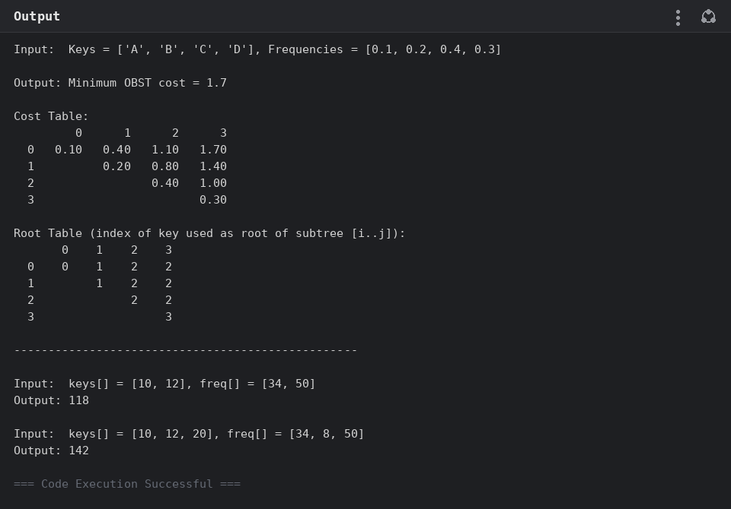

Experiment 16: Optimal Binary Search Tree — Integer Frequencies
Aim: Given keys 10, 12, 16, 21 with frequencies 4, 2, 6, 3, construct the Optimal Binary Search Tree and display its minimum cost, cost table, and root table.
Program:
def optimal_bst(keys, freq):
n = len(keys)
cost = [[0] * n for _ in range(n)]
root = [[0] * n for _ in range(n)]

for i in range(n):
cost[i][i] = freq[i]
root[i][i] = i

for length in range(2, n + 1):
for i in range(n - length + 1):
j = i + length - 1
cost[i][j] = float("inf")
freq_sum = sum(freq[i:j + 1])
for r in range(i, j + 1):
left = cost[i][r - 1] if r > i else 0
right = cost[r + 1][j] if r < j else 0
total = left + right + freq_sum
if total < cost[i][j]:
cost[i][j] = total
root[i][j] = r

return cost[0][n - 1], cost, root

def print_table(table, keys):
n = len(keys)
header = " " + " ".join(f"{j:>5}" for j in range(n))
print(header)
for i in range(n):
row = [f"{table[i][j]:>5.0f}" if j >= i and table[i][j] != float("inf") else " " for j in range(n)]
print(f" {i} " + " ".join(row))

keys = [10, 12, 16, 21]
freq = [4, 2, 6, 3]

min_cost, cost_table, root_table = optimal_bst(keys, freq)

print(f"Input: Keys = {keys}, Frequencies = {freq}")
print(f"\nOutput: Minimum OBST cost = {min_cost:.0f}")
print("\nCost Table:")
print_table(cost_table, keys)
print("\nRoot Table (index of key used as root of subtree [i..j]):")
print_table(root_table, keys)

print("\n" + "-" * 50 + "\n")

for k, f in [([10, 12], [34, 50]), ([10, 12, 20], [34, 8, 50])]:
result, _, _ = optimal_bst(k, f)
print(f"Input: keys[] = {k}, freq[] = {f}")
print(f"Output: {result:.0f}")
print()
Output:
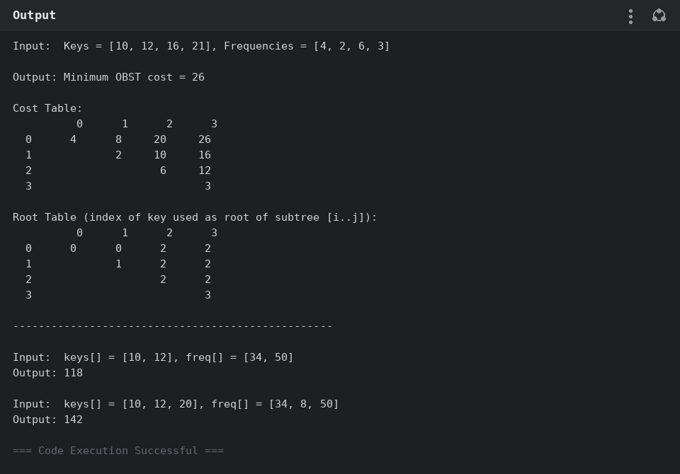

Experiment 17: Cat and Mouse Game
Aim: Given an undirected graph where a Mouse (starting at node 1) and a Cat (starting at node 2, forbidden from the hole at node 0) alternate optimal moves, use game-theoretic dynamic programming with memoization to determine whether the Mouse wins, the Cat wins, or the game is a draw.
Program:
from functools import lru_cache

DRAW, MOUSE_WIN, CAT_WIN = 0, 1, 2

def cat_mouse_game(graph):
n = len(graph)

@lru_cache(maxsize=None)
def solve(mouse, cat, turn, moves_left):
# turn: 0 = mouse to move, 1 = cat to move
if mouse == 0:
return MOUSE_WIN
if mouse == cat:
return CAT_WIN
if moves_left == 0:
return DRAW # position effectively repeats -> draw

if turn == 0:
best = CAT_WIN # worst case for mouse
for nxt in graph[mouse]:
result = solve(nxt, cat, 1, moves_left - 1)
if result == MOUSE_WIN:
return MOUSE_WIN
if result == DRAW:
best = DRAW
return best
else:
best = MOUSE_WIN # worst case for cat
for nxt in graph[cat]:
if nxt == 0:
continue # cat cannot enter the hole
result = solve(mouse, nxt, 0, moves_left - 1)
if result == CAT_WIN:
return CAT_WIN
if result == DRAW:
best = DRAW
return best

# A game that hasn't resolved within 2n(n-1) half-moves must be a draw
limit = 2 * n * (n - 1)
return solve(1, 2, 0, limit)

test_cases = [
[[2, 5], [3], [0, 4, 5], [1, 4, 5], [2, 3], [0, 2, 3]],
[[1, 3], [0], [3], [0, 2]],
]

for graph in test_cases:
result = cat_mouse_game(graph)
print(f"Input: graph = {graph}")
print(f"Output: {result}")
print()
Output:
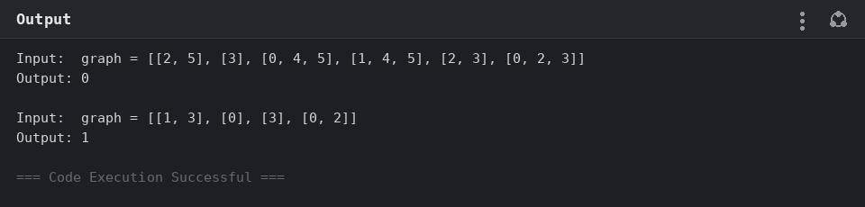

Experiment 18: Path with Maximum Probability
Aim: Given an undirected weighted graph where edge weights are success probabilities, find the path between two given nodes that maximizes the overall probability of success, using a Dijkstra-style priority-queue search.
Program:
import heapq
from collections import defaultdict

def max_probability(n, edges, succ_prob, start, end):
graph = defaultdict(list)
for (a, b), prob in zip(edges, succ_prob):
graph[a].append((b, prob))
graph[b].append((a, prob))

prob = [0.0] * n
prob[start] = 1.0
# Max-heap via negated probabilities
heap = [(-1.0, start)]

while heap:
neg_p, node = heapq.heappop(heap)
p = -neg_p
if node == end:
return p
if p < prob[node]:
continue
for neighbor, edge_prob in graph[node]:
new_prob = p * edge_prob
if new_prob > prob[neighbor]:
prob[neighbor] = new_prob
heapq.heappush(heap, (-new_prob, neighbor))

return prob[end]

test_cases = [
(3, [[0, 1], [1, 2], [0, 2]], [0.5, 0.5, 0.2], 0, 2),
(3, [[0, 1], [1, 2], [0, 2]], [0.5, 0.5, 0.3], 0, 2),
]

for n, edges, succ_prob, start, end in test_cases:
result = max_probability(n, edges, succ_prob, start, end)
print(f"Input: n = {n}, edges = {edges}, succProb = {succ_prob}, start = {start}, end = {end}")
print(f"Output: {result:.5f}")
print()
Output:
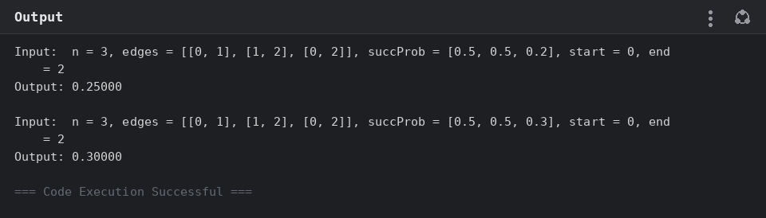

Experiment 19: Unique Paths on a Grid
Aim: Given an m x n grid, use dynamic programming to count the number of unique paths a robot can take from the top-left corner to the bottom-right corner, moving only right or down.
Program:
def unique_paths(m, n):
dp = [[1] * n for _ in range(m)]
for i in range(1, m):
for j in range(1, n):
dp[i][j] = dp[i - 1][j] + dp[i][j - 1]
return dp[m - 1][n - 1]

test_cases = [(3, 7), (3, 2)]

for m, n in test_cases:
result = unique_paths(m, n)
print(f"Input: m = {m}, n = {n}")
print(f"Output: {result}")
print()
Output:
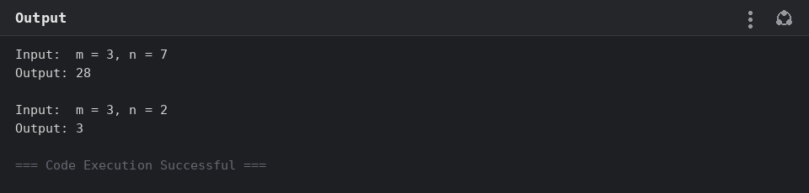

Experiment 20: Number of Good Pairs
Aim: Given an array of integers, count the number of index pairs (i, j) with i < j such that nums[i] equals nums[j], using frequency counts for an efficient O(n) solution.
Program:
from collections import Counter

def num_good_pairs(nums):
counts = Counter(nums)
return sum(c * (c - 1) // 2 for c in counts.values())

test_cases = [
[1, 2, 3, 1, 1, 3],
[1, 1, 1, 1],
]

for nums in test_cases:
result = num_good_pairs(nums)
print(f"Input: nums = {nums}")
print(f"Output: {result}")
print()
Output:
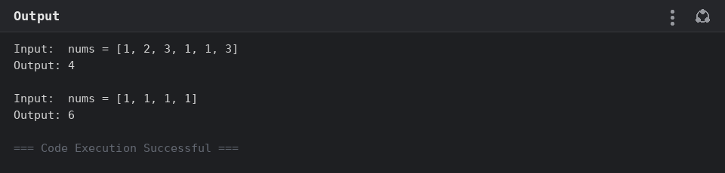

Experiment 21: City With the Smallest Number of Neighbors at a Threshold Distance
Aim: Given n cities connected by weighted, bidirectional edges and a distance threshold, use Floyd's algorithm to find the city that can reach the fewest other cities within the threshold, breaking ties by returning the city with the greatest index.
Program:
INF = float("inf")

def find_the_city(n, edges, distance_threshold):
dist = [[INF] * n for _ in range(n)]
for i in range(n):
dist[i][i] = 0
for u, v, w in edges:
dist[u][v] = min(dist[u][v], w)
dist[v][u] = min(dist[v][u], w)

for k in range(n):
for i in range(n):
for j in range(n):
if dist[i][k] + dist[k][j] < dist[i][j]:
dist[i][j] = dist[i][k] + dist[k][j]

best_city, best_count = -1, n + 1
for i in range(n):
count = sum(1 for j in range(n) if i != j and dist[i][j] <= distance_threshold)
if count <= best_count:
best_city, best_count = i, count

return best_city

test_cases = [
(4, [[0, 1, 3], [1, 2, 1], [1, 3, 4], [2, 3, 1]], 4),
(5, [[0, 1, 2], [0, 4, 8], [1, 2, 3], [1, 4, 2], [2, 3, 1], [3, 4, 1]], 2),
]

for n, edges, threshold in test_cases:
result = find_the_city(n, edges, threshold)
print(f"Input: n = {n}, edges = {edges}, distanceThreshold = {threshold}")
print(f"Output: {result}")
print()
Output:
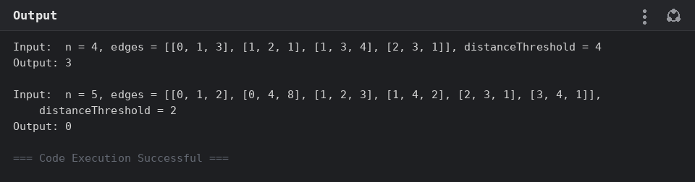

Experiment 22: Network Delay Time
Aim: Given a directed, weighted network of n nodes and a source node k, use Dijkstra's algorithm to find the minimum time for a signal sent from k to reach every node, or return -1 if some node is unreachable.
Program:
import heapq
from collections import defaultdict

def network_delay_time(times, n, k):
graph = defaultdict(list)
for u, v, w in times:
graph[u].append((v, w))

dist = {node: float("inf") for node in range(1, n + 1)}
dist[k] = 0
heap = [(0, k)]

while heap:
d, node = heapq.heappop(heap)
if d > dist[node]:
continue
for neighbor, weight in graph[node]:
new_dist = d + weight
if new_dist < dist[neighbor]:
dist[neighbor] = new_dist
heapq.heappush(heap, (new_dist, neighbor))

max_dist = max(dist.values())
return max_dist if max_dist < float("inf") else -1

test_cases = [
([[2, 1, 1], [2, 3, 1], [3, 4, 1]], 4, 2),
([[1, 2, 1]], 2, 1),
([[1, 2, 1]], 2, 2),
]

for times, n, k in test_cases:
result = network_delay_time(times, n, k)
print(f"Input: times = {times}, n = {n}, k = {k}")
print(f"Output: {result}")
print()
Output:
